**LAB #12**

**Name:** Hassan Farooq Siddiqi

**Roll NO:** 099

**Section: BBSE-2A**

**Code:**

**Avl Insertion, Deletion & Traverse**

#include<iostream>

using namespace std;

struct Node {

int key, height;

Node *left, *right;

Node(int k = 0) {

key = k;

left = nullptr;

right = nullptr;

height = 1;

}

};

class Avl {

Node* root;

int max(int a, int b) {

return (a > b) ? a : b;

}

int height(Node* N) {

if (N == nullptr) return 0;

return N->height;

}

Node* rightRotate(Node* y) {

Node* x = y->left;

Node* t2 = x->right;

// Perform rotation

x->right = y;

y->left = t2;

// Update heights

y->height = 1 + max(height(y->left), height(y->right));

x->height = 1 + max(height(x->left), height(x->right));

//return a new noot

return x;

}

Node* leftRotate(Node* x) {

Node* y = x->right;

Node* t2 = y->left;

// Perform rotation

y->left = x;

x->right = t2;

// Update heights

x->height = 1 + max(height(x->left), height(x->right));

y->height = 1 + max(height(y->left), height(y->right));

//return a new noot

return y;

}

Node* minValueNode(Node* node) {

Node* current = node;

while (current && current->left != nullptr)

current = current->left;

return current;

}

Node* deleteNodeHelper(Node* node, int key) {

if (node == nullptr) return node;

if (key < node->key)

node->left = deleteNodeHelper(node->left, key);

else if (key > node->key)

node->right = deleteNodeHelper(node->right, key);

else {

// Node with only one child or no child

if (node->left == nullptr || node->right == nullptr) {

Node* temp = node->left ? node->left : node->right;

// No child case

if (temp == nullptr) {

temp = node;

node = nullptr;

}

else { // One child case

*node = *temp; // Copy the contents

}

delete temp;

}

else {

// Node with two children: Get inorder successor

Node* temp = minValueNode(node->right);

node->key = temp->key;

node->right = deleteNodeHelper(node->right, temp->key);

}

}

// If the tree had only one node then return

if (node == nullptr) return node;

// Update height

node->height = 1 + max(height(node->left), height(node->right));

// Rebalance the node

int balance = getBalancedFactor(node);

// Left Left Case

if (balance > 1 && getBalancedFactor(node->left) >= 0)

return rightRotate(node);

// Left Right Case

if (balance > 1 && getBalancedFactor(node->left) < 0) {

node->left = leftRotate(node->left);

return rightRotate(node);

}

// Right Right Case

if (balance < -1 && getBalancedFactor(node->right) <= 0)

return leftRotate(node);

// Right Left Case

if (balance < -1 && getBalancedFactor(node->right) > 0) {

node->right = rightRotate(node->right);

return leftRotate(node);

}

return node;

}

Node* insertNode(Node* node, int key) {

// Perform the normal BST insertion

if (node == nullptr)

return new Node(key);

if (key < node->key)

node->left = insertNode(node->left, key);

else if (key > node->key)

node->right = insertNode(node->right, key);

else // Equal keys are not allowed in BST

return node;

// Update height of this ancestor node

node->height = 1 + max(height(node->left), height(node->right));

// Get the balance factor of this ancestor node

int balance = getBalancedFactor(node);

// If this node becomes unbalanced,

// then there are 4 cases

// Left Left Case

if (balance > 1 && key < node->left->key)

return rightRotate(node);

// Right Right Case

if (balance < -1 && key > node->right->key)

return leftRotate(node);

// Left Right Case

if (balance > 1 && key > node->left->key) {

node->left = leftRotate(node->left);

return rightRotate(node);

}

// Right Left Case

if (balance < -1 && key < node->right->key) {

node->right = rightRotate(node->right);

return leftRotate(node);

}

// Return the (unchanged) node pointer

return node;

}

public:

Avl() {

root = nullptr;

}

int getBalancedFactor(Node* node) {

if (node == nullptr) return 0;

return height(node->left) - height(node->right);

}

void insert(int key) {

root = insertNode(root, key);

}

void deleteNode(int key) {

root = deleteNodeHelper(root, key);

}

void inorder(Node* node) {

if (node == nullptr) return;

inorder(node->left);

cout << node->key << " -> ";

inorder(node->right);

}

void preorder(Node* node) {

if (node != nullptr) {

cout << node->key << " ";

preorder(node->left);

preorder(node->right);

}

}

Node* getRoot() const { return root; }

};

int main() {

int nodes[] = { 10,20,30,40,50,25};

Avl avl;

for (int key: nodes)

{

avl.insert(key);

}

cout << "Preorder traversal before deletion: ";

avl.preorder(avl.getRoot());

cout << endl;

avl.deleteNode(30); // Delete node with key 30

cout << "Preorder traversal after deletion: ";

avl.preorder(avl.getRoot());

cout << endl;

return 0;

}

**Output:**

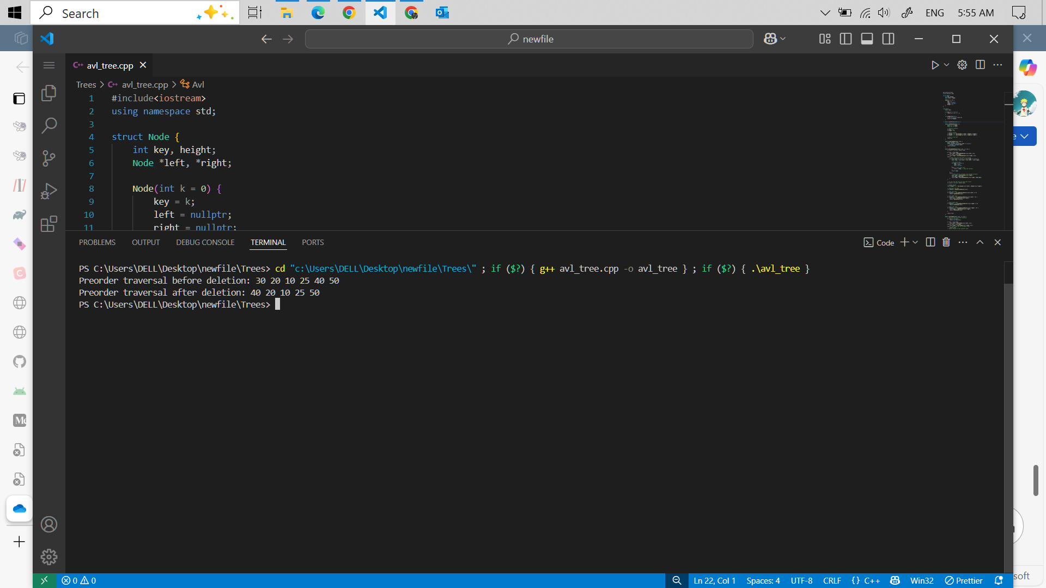

**Code:**

**BST Insertion, Deletion & Travrese**

#include <iostream>

using namespace std;

/*

Trees is basically have multiple Nodes but BST is have only two Node left and right

BST have two rules ...the Next newNode will be linked if its samller than the root Node it will linked on left side and if its bigger than the root Node it will linked on right side

BST Have

1--- insert ,

3--- search

4--- update

*/

struct Node

{

int key;

Node *left, *right;

Node(int k= 0);

~Node(){

delete left , right;

left = nullptr;

right = nullptr;

}

};

Node::Node(int k )

{

{

key = k;

left = right = nullptr;

}

}

class Binary_search_tree

{

private:

Node *root;

Node* deleteNode(Node* rootNode , int k){

/*

7

5 8

4 6 90

*/

if(!rootNode ) return nullptr; //Base Case

//search for Node

if(k <rootNode->key){

rootNode->left = deleteNode(rootNode->left,k);

}else if(k > rootNode->key){

rootNode->right = deleteNode(rootNode->right,k);

}else {

//Node found -now delete it

//case 1 : No Child or one child

if(!rootNode->left){

Node* temp = rootNode->right;

delete rootNode;

return temp;

}else if(!rootNode->right) {

Node* temp = rootNode->left;

delete rootNode;

return temp;

}

//case 3: Two Children

Node* successor = findMin(rootNode->right);

rootNode->key = successor->key;

rootNode->right = deleteNode(rootNode->right,successor->key);

}

return rootNode;

}

public:

Binary_search_tree(){

root = nullptr;

}

~Binary_search_tree(){};

void insert(int k)

{

Node *newNode = new Node(k); // 10

if (root != nullptr)

{

Node *temp = root;

while (true)

{

if (k <temp->key)

{

if(temp->left == nullptr){

temp->left = newNode;

break;

}

// Left side

temp = temp->left;

}

else

{

// RIght side

if(temp->right == nullptr){

temp->right = newNode;

break;

}

temp = temp->right;

}

}

// cout<<"Added Successfully.\n";

}

else

{

root = newNode;

}

}

void delete_Node(int k)

{

root = deleteNode(root,k);

}

Node* findMin(Node* node ){

while (node->left != nullptr)

{

node = node->left;

}

return node;

}

void search(int k)

{

if (root != nullptr)

{

Node *temp = root;

while (temp != nullptr && temp->key != k )

{

if (k > temp->key)

{

temp = temp->right;

}else if(temp == nullptr){

break;

}

else

{

temp = temp->left;

}

}

if (temp->key == k && temp != nullptr)

{

cout << "\nFound Out. \n Address : " << temp;

}

else

{

cout << "Not Found Out.\n";

}

}

else

{

cout << "Tree is Empty.\n";

}

}

void update(int d, int newValue)

{

Node *temp = root;

while (temp->key != d)

{

if (d > temp->key)

{

temp = temp->right;

}

else

{

temp = temp->left;

}

}

temp->key = newValue;

if (temp->key == newValue)

{

cout << "Value Updated Successfully.\n";

}

else

{

cout << "Error While Updating the Value.\n";

}

}

void inorder(Node* root)

{

if(root == nullptr) {

return ;

}else {

inorder(root->left);

cout<<root->key<<" -> ";

inorder(root->right);

}

}

void preOrder(Node* root){

if(root == nullptr){

return ;

}else{

preOrder(root->left);

postOder(root->right);

cout<<root->key<<" -> ";

}

}

void postOder(Node* root){

if(root == nullptr){

return ;

}else {

cout<<root->key <<" -> ";

postOder(root->left);

postOder(root->right);

}

}

Node* getRoot(){

return root;

}

};

int main()

{

int keys[5] = { 90,2 ,8,7,91};

Binary_search_tree bst;

for(int key : keys){

bst.insert(key);

}

cout<<"Pre-order Traverse : ";

bst.preOrder(bst.getRoot());

cout<<endl;

bst.delete_Node(8); //Deleting 8 key

cout<<endl;

cout<<"Pre-order Traverse : ";

bst.preOrder(bst.getRoot());

cout<<endl;

}

**Output:**

